Documentation for Solidworks to Mujoco:

1. Exporting from Solidworks using SW2URDF:
   1. Step 1: Download SW2URDF extension
      1. Repo: <https://github.com/ros/solidworks_urdf_exporter/releases>
   2. Step 2: Assigning frames to your robot
      1. [(170) Frame Assignment For Robotic Manipulators - Direct Kinematics I - YouTube](https://www.youtube.com/watch?v=fNIyNF87q9I&t=244s)
      2. ^ this video should give you a good idea of what assigning frames is and how to know where to place your frames.
      3. Use the Reference geometry 🡪 Coordinate system tool in Solidworks.
         1. A useful tip: Point your coordinate systems toward each other if possible – this will make it easier to code in mujoco later.
   3. Step 3: Using the extension
      1. Follow this video tutorial: <https://www.youtube.com/watch?v=ge3P307TgJI>
      2. Now you should have a folder with the URDF of your robot.
2. Accessing the URDF and verifying the urdf:
   1. Ref:
      1. <https://mujoco.readthedocs.io/en/latest/modeling.html#curdf>
      2. [urdf - ROS Wiki](http://wiki.ros.org/urdf)
   2. Step 1: Checking if your URDF generated correctly:
      1. Add the mujoco extension after robot name like so:

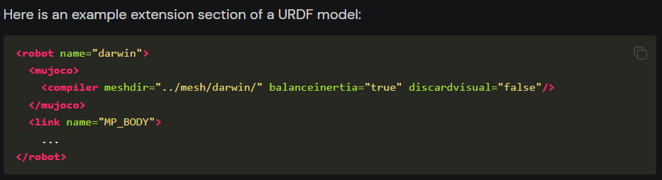

* 1. Step 2: Check the URDF for collision/joint problems:
     1. After you add the extension, you should be able to drag and drop the file into mujoco and 2 things can happen:
        1. Everything runs < less interesting
        2. Everything runs itself apart < more interesting
           1. If this was the case, you could be running into a collision issue.
           2. You can confirm this by tapping F to toggle the forces vectors and H to toggle the convex hull

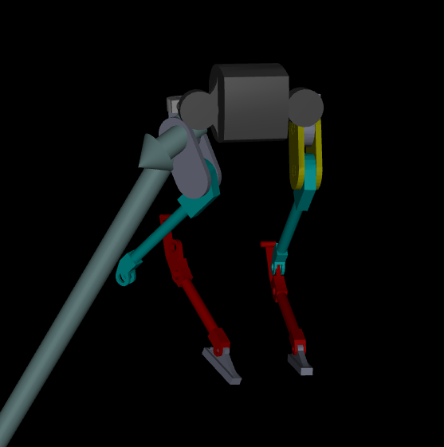

So, as you can see, there is a huge force coming off the body and the knee joint not being connected.

* + 1. Fixing Joints:
       1. Go back to Solidworks and check how the urdf was generated, make sure all the frames and joint types are correct and regenerate the urdf.
    2. Fixing collision:
       1. Check which part is colliding by hitting the H-key on your keyboard.
          1. Note: if a collision geometry was not specified, mujoco will automatically generate it, but it messes up sometimes.
       2. Solution: in the URDF, replace the collision mesh with something else by changing the name of the collision geometry mesh to the new mesh.
  1. Step 3: Verifying your URDF on Linux:
     1. Use the following command on Linux terminal to verify the URDF:
        1. rosrun urdfdom check_urdf /path2model/<model>.urdf
     2. This should output the kinematic tree of your robot.
        1. 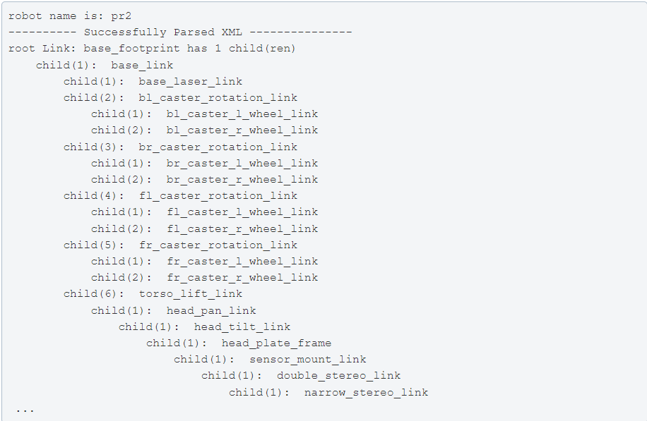

1. Converting URDF to MUJOCO xml:
   1. Ref:
      1. [wangcongrobot/dual_ur5_husky_mujoco: Dual UR5 Husky Robot MuJoCo Model (github.com)](https://github.com/wangcongrobot/dual_ur5_husky_mujoco)
   2. Enter the path ~/mujoco/mujoco200/bin first and run command below:
   3. Convert the urdf:
      1. compile /path/to/model.urdf /path/to/model.xml
   4. Test:
      1. mujoco200/bin$ ./simulate /path/to/model.xml

Congratulations! You are now able to run mujoco with your robot design! Add more mujoco tags as needed